About the Canadian Ski Patrol

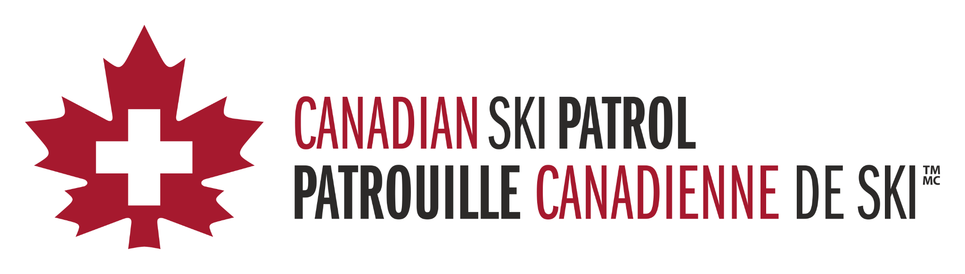

The Canadian Ski Patrol is comprised of more than 4,000 volunteers across Canada. The CSP provide their first aid and rescue services at resorts across Canada, including right here at **Resort Name**.

Each patroller who joins the CSP is trained to handle a multitude of medical conditions. Patrollers are ready to intervene in any situation that may arise on and off the snow.

The CSP’s advanced first-aid course is a minimum of 60 hours in length and includes CPR, AED, and WHMIS training. Patrollers must re-certify their first-aid qualifications every year by completing a refresher course that is a minimum of 16 hours. Patrollers must demonstrate their understanding by passing a written, skills, diagnostic and CPR/AED exam.

Over the past two decades, the services offered by the CSP have expanded beyond ski resorts. CSP members provide first aid services, medical support, and coordination of a medical team for a range of sporting activities and community events throughout the year.

Recruiting occurs all year long. However, most recruitment activity occurs during the months of August and September.

The CSP welcomes new members who want to make a difference in their community. Begin your adventure with the Canadian Ski Patrol today! Visit joinskipatrol.ca to register with your local zone.

Additional Links:
Join The Canadian Ski Patrol: https://www.skipatrol.ca/join/
FAQs about The Canadian Ski Patrol: https://www.skipatrol.ca/faqs/
Find Your Local CSP Zone: https://www.skipatrol.ca/where-we-play/

